**User Story :**

🡪 simply refers to the simple general explanation of specific software feature written from the perspective of an end user

🡪core components/building blocks of an agile framework

**Writing User stories :**

User stories follow a standard template as follows :

As a <type of user> ,I want to <goal> so that I can <purpose>

Example :

* **As a** trainer,
* **I want** my profile to list my upcoming classes and include a link to a detailed page about each
* **so that** prospective attendees can find my courses.

Stories are Written throughout the Agile Project by each member

Later Teams will write product backlogs that fully describes the functionality to be added over the course of project

**3 C’s of a user story :**

**i)Cards :** cards/digital cards are where user stories are written and are discussed which explains the specific user requirement without much details.

ii)**Conversation :** the requirements are discussed further, refined, validated and given to the developers

ii) **Confirmation :** involves acceptance test which determines the acceptability of the product.

**User Story :**

🡪user story is the smallest unit of work which is an end goal and not a feature from the software user’s perspective.

🡪they are few sentences in a simple language that outline the desired outcome.

🡪used in agile frameworks like scrum ,kanban , Epics, Initiatives :

i)In scrum the stories are added and are completed over certain duration of the sprint.

ii)In kanban, teams pull user stories into their baclog and run them through their workflow.

iii)  Epics are large work items broken down into a set of stories, and multiple epics comprise an initiative.

**Acceptance Criteria for User Stories**

Acceptance Criteria in user stories are detailed conditions that a software product must satisfy to be considered complete and to meet the user's requirements.

**Definition:** Acceptance Criteria are a set of conditions or requirements that must be met for a user story to be considered complete.

**Purpose:** They serve as guidelines for developers and testers to understand the boundaries of a user story and to verify whether it has been implemented correctly.

**Detailing Expectations:** Acceptance Criteria provide clarity and specificity to user stories, outlining exactly what needs to be done to fulfill the user's needs.

**Good Acceptance Criteria:**

**Clear and Understandable**: They should be written in clear, simple language that is understandable to all stakeholders.

**Testable:** Each criterion should be verifiable, meaning it should be possible to determine whether it has been met through testing.

**Relevant:** They should directly address the functionality or feature described in the user story**.**

**Components of Acceptance Criteria:**

Description🡪 A brief description of the condition or requirement.

Input🡪Any necessary input or preconditions required for the condition to be tested.

Expected Outcome🡪The expected result or behavior when the condition is met.

**Examples:**

i)User Story: As a user, I want to be able to log in to the system.

**Acceptance Criteria:**

The login page should have input fields for username and password.

Upon entering valid credentials and clicking "Login", the user should be directed to their dashboard.

Entering invalid credentials should display an error message.

ii)User Story: As a customer, I want to be able to filter products by category.

**Acceptance Criteria:**

The product listing page should have a filter option for categories.

Selecting a category should update the product list to display only products in that category.

The filter should support selecting multiple categories simultaneously.

**Importance**

**Alignment:** They ensure that the development team and stakeholders are aligned on the expectations for the user story.

**Quality Assurance**: They help QA teams in planning and executing tests to validate the functionality.

**Minimizing Misunderstandings**: Clear criteria reduce the likelihood of misunderstandings or misinterpretations of requirements.

**Risk Mitigation:** They help identify potential gaps or missing requirements early in the development process, reducing the risk of delivering unsatisfactory or incomplete features**.**

**Scrum:**

Scrum is a management framework that teams use to self-organize and work towards a common goal. It describes a set of meetings, tools, and roles for efficient project delivery. Much like a sports team practicing for a big match, Scrum practices allow teams to self-manage, learn from experience, and adapt to change. Software teams use Scrum to solve complex problems cost effectively and sustainably.

The INVEST acronym is applied to user stories by Scrum teams. It measures the user story to see if it can be completed in a sprint. It stands for:

* Independent (not dependent on other work deliverables).
* Negotiable (allows for best practices),
* valuable (provides working functionality).
* Estimable (allows clear work estimates).
* Small (sized for the team's sprint).
* Testable (can be measured to ensure it meets customer expectations).

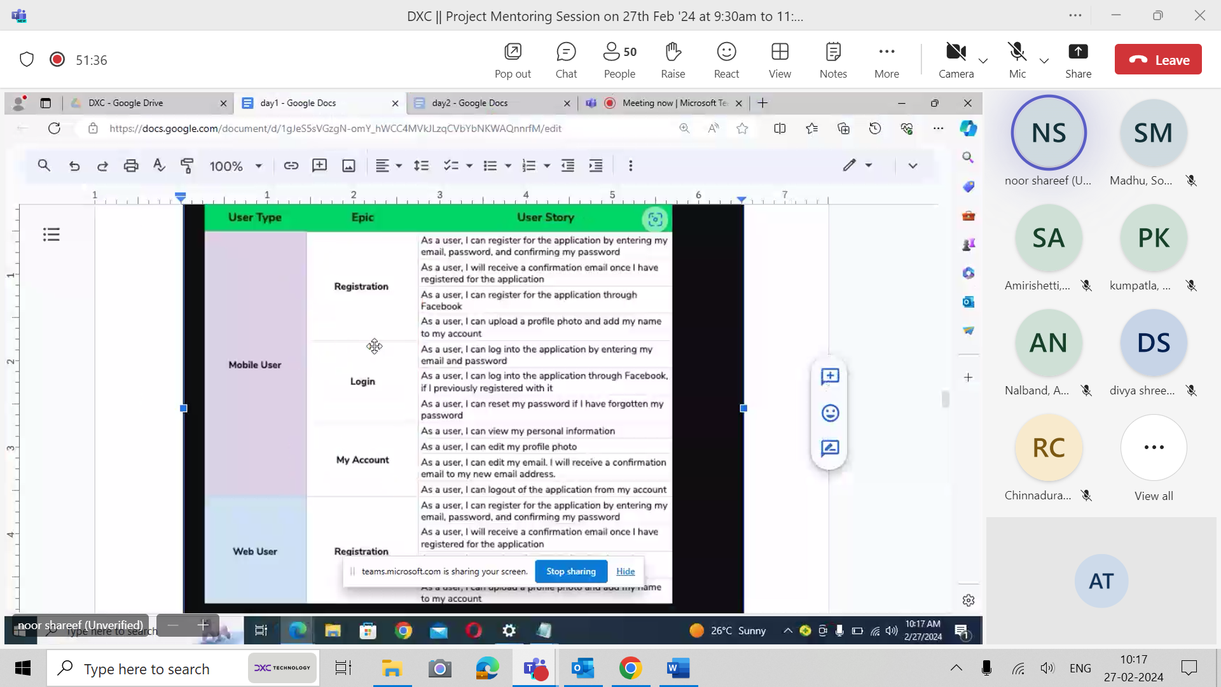

**Learning Platform:**

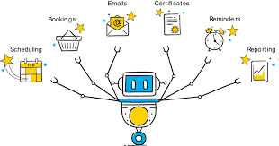

**Build User Stories :**

|  |  |  |
| --- | --- | --- |
| **User Type** | **Epic** | **User Stories** |
| **Student** | Registration | 1.As a user I can register for the course with my email and password.  2.As a user I will receive a verification code for account confirmation.  3.As a user I get access to the application dashboard. |
|  | login | 1.As a user I can log into my account with my account email and password.  2.As a user I can reset my password if I have forgotten my password.  3.As a user I can view my personal information. |
|  | My Account | 1.As a user I can view my personal information.  2.As a user I can upload my profile photo.  3.As a user I can logout from my account whenever I want. |
|  | Course Registration | 1.As a user I register for any course available.  2.As a user I can filter out my search using skills I require. |
|  | Payment | 1.As a user I will be directed to the payment page after selecting a course.  2.As a user I will have several payment methods(UPI,NETBANKING,CREDIT CARD,DEBIT CARD) for transaction.  3.As a user I will receive confirmation email after successful payment. |
|  | Access | 1.As a user, I will have access to the course I have subscribed after successful payment.  2.As a user, I will be provided with Certification after course completion. |

